37.34: a) b)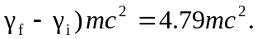
c) The result of part (b) is far larger than that of part (a).

